An interesting report on Irish mortgage actions, courtesy of the Times

Ireland's Four Courts master Ed Honohan takes on the debt dilemma, attempting to settle disputes between debtors and banks

There are few winners as Ed Honohan tries to sort out disputes between debtors and banks

**Mark Tighe**

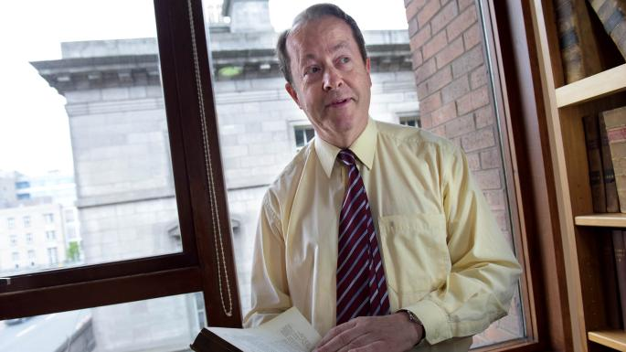

Honohan is adamant that evictions should be a last resortBRYAN MEADE

Share

Save

In a small court on the second floor of the east wing of the Four Courts sits Ed Honohan, master of the High Court. A non-judicial role, the master deals with about 100 cases a day, most of which involve debt recovery.

Unlike judges, who tend not to speak out on political and policy issues, Honohan is an outspoken critic of banks and has said he wants to ensure evictions are a last resort. Following AIB complaints about how difficult it is to “realise security over loans”, The Sunday Times spent a morning in Honohan’s court, through which most High Court debt cases must pass.

The master can issue judgments when there is agreement between parties. In disputed cases or those where debtors have not responded to summonses, the master will decide whether court rules have been followed before letting the case go forward to be heard by a judge.

Last Tuesday proves a bruising day for the banks and their lawyers. Initially, a judgment of €239,000 is given on consent but then dozens of cases are adjourned to later dates by agreement between the parties. Honohan says this is a “funny pattern”, as most cases seem to be heading towards settlement.

“Judges will be asking what happened to the flow of cases of banks seeking judgment,” he says. In a voice laden with sarcasm he adds: “The answer, of course, is that the defendants have the money to pay off their debts.”

In a case AIB has taken against a married couple, Honohan becomes angry after reviewing the file. When it was previously before a High Court judge, a costs order was made by the judge Robert Eagar against the couple, on an ex parte basis, meaning only the bank’s lawyers were in court. AIB’s barrister explains the order was issued after threats were made against its summons server.

Honohan insists a cost order cannot be made against people not in court to defend themselves. He tells AIB to “go back to Judge Eagar and tell him” the master is not happy with the ex parte costs order.

The next case involves AIB seeking possession over 25 hectares (62 acres) of land in Waterford. The debtor lives abroad. Honohan is told the summons was served by registered post on the debtor’s solicitor. The master says, although the defendant has a solicitor in a different case, that solicitor is not “on record” in these proceedings. He admonishes the barrister, telling him this is “basic stuff” he should have learnt as an undergraduate.

“You don’t serve a summons on a solicitor,” Honohan points out.

He questions whether AIB complied with “order nine, rule 14”, which requires a check on whether third parties have an interest in the land, such as someone renting it to sow crops or graze cattle. “There might be cows on it,” he suggests.

The barrister wants the case transferred to a judge. Instead Honohan adjourns it because the summons was not properly served. The barrister shakes his head in frustration. As he is leaving, the lawyer does a theatrical shrug to the packed court when he hears that the next case also involves AIB seeking to transfer a debt case to a judge.

Honohan asks the next barrister if “order 9” has been complied with. “We’re not having much fun with this, are we?” he remarks to the female lawyer. In this case AIB wants a judgment against a Galway man’s house based on a 2003 mortgage.

Looking at the paperwork, Honohan says AIB’s official has added “extra words” in his affidavit, describing the mortgage’s terms in an attempt to “tidy up” the record. “It’s called an untruth,” the master states. He asks if the barrister would like an adjournment. Suddenly, she would. It goes back to January 29.

The next case involves Promontoria, a subsidiary of Cerberus, a US private equity fund that bought distressed debt from Ulster Bank. It wants an order to allow it to sell a debtor’s land. Having examined the paperwork, Honohan believes a solicitor gave undertakings that do not apply to the land in question. The US fund is “misstating the facts” surrounding the purchase of the property in its affidavit, he insists. The master says Promontoria “should apologise” and pay the defendant’s costs.

“You may have paid Ulster Bank a few bob [to buy the distressed mortgage] but it turns out to be a dud investment,” he warns. “Go and get your money back.”

The next case involves Ulster Bank seeking a judgment against a 78-year-old man. Honohan is asking how the papers were served when the elderly defendant stands up in court. Honohan tells the man that, although there is a problem with the summons, that is “water under the bridge” because he is in court. However, the master finds the bank failed to exhibit a “land certificate”, so he adjourns the case until January 15.

The next case involves a bread delivery man being pursued by Revenue. Representing himself, the man tells the judge he had cancer and lost work as “people weren’t eating the right type of bread”. Honohan observes that the man is not in a position to pay his tax debt until he gets back on his feet. The master tries to direct the man to seek an adjournment. The man does not take the hint.

“I can’t keep prompting,” complains Honohan. “You could say you were in a state of shock and ask for time.” When the man finally agrees, Honohan adjourns the case until January 15.

The solicitor for Revenue seems to look frustrated as she collects the file from Honohan’s registrar.