The fairy tale world of Drew Harris

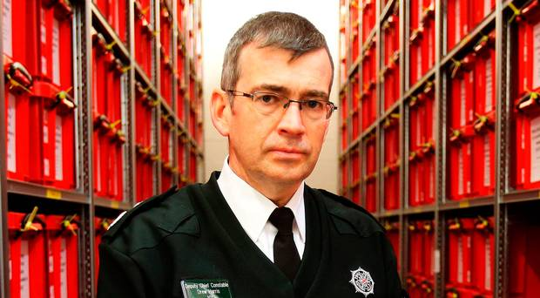

**1**

**1**

*Some PSNI officers have "washed their hands" of welfare issues, a former sergeant has said.*

*But the force's Deputy Chief Constable Drew Harris disputed the claim and said 398 officers and staff used a special helpline over the last 10 months, while 169 had received counselling.*

*The police's occupational health department offered almost 900 appointments a month.*

*Some officers present with symptoms consistent with post-traumatic stress disorder following a service involving difficult events dating back to the Troubles and more recently.*

*Mr Harris said: "Our society is becoming more fraught so more is required of us, and other front line responders."*

*He added: "Vulnerability and then the crime and tragedy that comes from that is increasing in our society, you see that.*

*"It is very different from when I joined the police. In effect, we are a small number of people dealing with more of this stuff."*

*The ex-sergeant, who left the force in 2013, said civilianisation as part of peace process reforms made the system inflexible and less human.*

*"If you are an officer now and you can wash your hands of it and say we have the staff to do that, it does not have to touch you or blemish your copybook or alter your promotion."*

*He said he twice faced unsubstantiated and unfounded workplace allegations, and that he was made to feel like a criminal, "guilty until proven innocent".*

*He said: "Years ago officers were forged in fire, they had been through terrible times, they had witnessed friends dying, they had commanded over losing men.*

*"Nowadays, you have an officer coming up who has no responsibility or has, what the Tories in Government like to talk about, their portfolio. And that is his responsibility, full stop."*

*The officer's own mental health difficulties were partly linked to the death of a colleague who shot himself. He said he had raised unprocessed files with the dead man, although he said the victim killed himself over an unrelated reason, leaving two children behind.*

*He said: "I dissolved, I could not stand up, I chain-smoked, I cried, the wife did not know what had happened, she could not understand. I could not sleep or eat, in your head was only: 'why'?."*

*Mr Harris said the PSNI had invested heavily in occupational health, and modern grievance procedures had been in place 15 years.*

*Meanwhile, the Police Federation for Northern Ireland has said the time police spend waiting to see a psychologist has fallen from 19 weeks to 10 days.*

*Federation chairman Mark Lindsay said the group, which represents rank-and-file officers, had put in £1m of its own members' money to speed up processes and improve resilience. "Policing is a very high-pressured environment which over an officer's career sees them build up quite traumatic experiences over a long number of years.*

*"This is all combined with the everyday pressures and stresses and strains that we see.*

*"There needs to be proper cognisance taken of the impact that this environment has on people's mental health."*

*Belfast Telegraph*

This article appeared recently in the Belfast Telegraph. Deputy Chief Constable Harris, pictured among some of the thousands of files he and his MI5 buddies never want you to see, waxed lyrical about what a caring organization is the PSNI.

The truth is different. Here is what Hanna Q.C. told the Court of Appeal when representing the Chief Constable.

*26. However, merely because psychiatric ill health had become a reasonably foreseeable consequence of severe traumatic exposure after late 1986, it did not follow that the respondent would thereupon, and without more, become subject to any factual duty to take specific action of some kind, pursuant to his employer's notional duty of care to provide a safe system of working. This is because, among other things, an employer can only reasonably be expected to take steps which are likely to do some good, and the court is likely to need expert evidence on this.*

The Chief Constable sought to escape any blame or responsibility for treating PTSD in his force. This is what the Court of Appeal said :

***[56]****In these circumstances, we find it impossible to say that the respondent is entitled to assert a complete and comprehensive immunity from liability to provide treatment. True it is that the only instance where the duty of an employer to treat employees for stress-related work conditions has been accepted is in the Multiple claimants v MoD case. It is also unquestionably correct that the armed services occupy a unique position in relation to the provision of health care that distinguishes them from most members of the public. But these circumstances cannot be regarded as determinative of the issue and we have, in any event, reached the conclusion that we have arrived at without reference to any possible analogy with members of the armed forces.*

***[57]****What makes the position of RUC members unique, at least in recent UK history, is that they have been a force exposed on a regular basis to a level of trauma not experienced elsewhere. At the time that treatment (as well as diagnosis) of psychiatric and psychological problems within the RUC was being undertaken, the respondent was being told by his OHU team of the inadequacies of referrals to outside agencies. A stark dilemma was presented to him. Should those who were at risk of developing these conditions (or, even worse, had already suffered from them) be further exposed to circumstances that would either precipitate or exacerbate those problems without the prospect of adequate treatment or should he ensure that treatment was available from the resources of the force itself? We consider that a blanket exemption from a duty to treat cannot in those circumstances be justified.*

So the deeply caring PSNI spoken about by Harris is not a creature of senior command but a direction from the Judges.

As for the Police Federation, I’ll leave that till another day…..